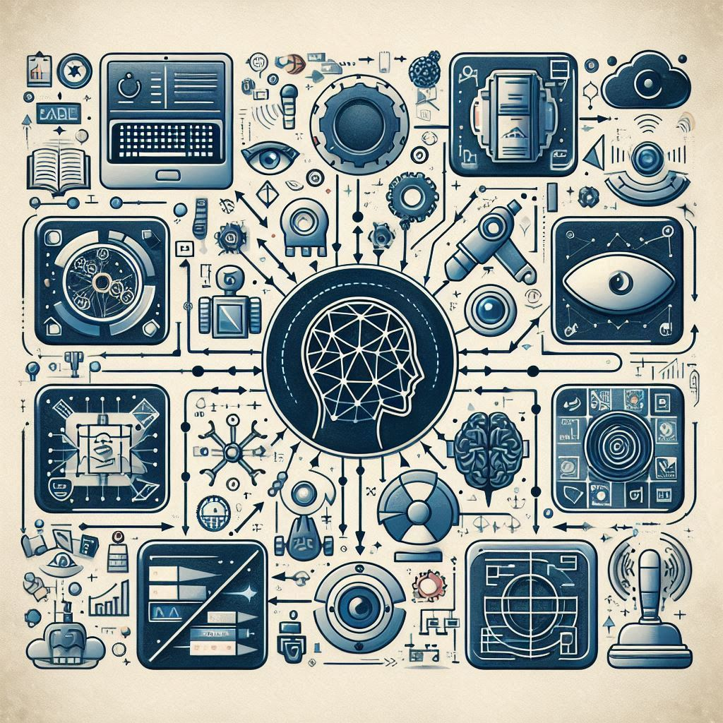**AI Tools**

1. Chatbot
   * ChatGPT - <https://www.openai.com/chatgpt>
   * Rungway - <https://www.rungway.com>
   * Pictory - <https://www.pictory.ai>
   * Bing - <https://www.bing.com>
2. Productivity Tools
   * Notion AI - <https://www.notion.so/product/ai>
   * Taskade - <https://www.taskade.com>
   * MeetGeek - <https://www.meetgeek.ai>
   * Ioni.ai - <https://www.ioni.ai>
   * AI Agents - <https://www.aiagents.com>
   * Emma - <https://www.emma.ai>
   * GPTBots - <https://www.gptbots.com>
   * Venturefy - <https://www.venturefy.com>
   * Bardeen AI - <https://www.bardeen.ai>
3. Design Tools
   * Midjourney - <https://www.midjourney.com>
   * Adobe Firefly - <https://www.adobe.com/sensei/generative-ai/firefly.html>
   * Microsoft Designer - <https://designer.microsoft.com>
4. Website Tools
   * 10web - <https://www.10web.io>
   * Durable - <https://www.durable.co>
   * Imagica - <https://www.imagica.com>
5. Code Tools
   * Copilot X - <https://github.com/features/copilot-x>
   * AskCodie - <https://www.askcodie.com>
   * AWS Chime SDK - <https://aws.amazon.com/chime/chime-sdk/>
   * DeepCode - <https://www.deepcode.ai>
   * Amazon CodeWhisperer - <https://aws.amazon.com/codewhisperer>
   * Android Studio Bot - <https://developer.android.com/studio>
   * Codiga - <https://www.codiga.io>
   * CodeWP - <https://www.codewp.ai>
   * PolyCoder - <https://www.polycoder.com>
6. Content Tools
   * ChatGPT Plugins Beta - <https://www.openai.com/chatgpt/plugins>
   * Cohere Summarize API - <https://cohere.ai>
   * Synthesia - <https://www.synthesia.io>
7. Presentation Tools
   * Tome - <https://tome.app>
   * Decktopus - <https://www.decktopus.com>
   * Gamma - <https://gamma.app>
8. Automation Tools
   * Zapier - <https://www.zapier.com>
   * Make.com - <https://www.make.com>
   * Bardeen - <https://www.bardeen.ai>
9. Image Tools
   * Visuali - <https://www.visuali.io>
   * Kiri.Art - <https://www.kiri.art>
   * AI Emoji Generator - <https://www.aiemojigenerator.com>
   * PortraitPro.ai - <https://www.portraitpro.ai>
   * Ink With AI - <https://www.inkwithai.com>
   * Closeup.ai - <https://www.closeup.ai>
10. SEO Tools
    * MarketMuse - <https://www.marketmuse.com>
    * Whalensync - <https://www.whalensync.com>
    * SEMrush - <https://www.semrush.com>
    * Grammarly - <https://www.grammarly.com>
    * HubSpot - <https://www.hubspot.com>
    * DeepBrain AI - <https://www.deepbrainai.com>
11. Music Life Tools
    * Spellar AI - <https://www.spellar.ai>
    * ELSA - <https://www.elsa.ai>
    * Sibyl AI - <https://www.sibyl.ai>
    * Notion AI - <https://www.notion.so/product/ai>
    * Taskade - <https://www.taskade.com>
    * Vondy AI - <https://www.vondy.ai>
12. YouTube Tools
    * Kittl - <https://www.kittl.com>
    * Wondershare Virbo - <https://www.wondershare.com/virbo>
    * Vocol AI - <https://www.vocol.ai>
    * Pictory - <https://www.pictory.ai>
    * ClipMaker - <https://www.clipmaker.com>
    * Steve.AI - <https://www.steve.ai>
13. Writing Tools
    * Copy AI - <https://www.copy.ai>
    * Article Forge - <https://www.articleforge.com>
    * Jasper - <https://www.jasper.ai>
    * Scalenut - <https://www.scalenut.com>
    * Sudowrite - <https://www.sudowrite.com>
    * Writesonic - <https://www.writesonic.com>
14. Twitter Tools
    * Tweety AI - <https://www.tweety.ai>
    * Twitwriter - <https://www.twitwriter.com>
    * TweetEev - <https://www.tweetev.com>
    * Buffer - <https://www.buffer.com>
    * Twesocial - <https://www.twesocial.com>
    * TweetHunter - <https://www.tweethunter.io>